What is PBIS?
PBIS puts an emphasis on school-wide systems of support that include proactive strategies for defining, teaching, and supporting appropriate student behaviors to create positive school environments. The purpose of school-wide PBIS is to establish a climate in which appropriate behavior is the norm.
Some Key Elements of PBIS
- Define expectations for students and provide direct instruction (modeling).
- Set up reward systems that use creative and individualized rewards.
- Staff will use positive language and provide immediate feedback.

For more information, please visit:
https://www.pbis.org

Our Voice Level Chart
(Voice level expectations are embedded in the school matrix shown on the inside of this brochure.)

Oak Grove Elementary
40 kerr road
Poughkeepsie, New York 12601
(845) 298-5280

Oak Grove P.B.I.S
Positive Behavioral Interventions & supports



The mission of Oak Grove PBIS is to promote positive behavior. By developing a safe and nurturing school climate we will empower our students to become respectful and responsible members of our community.

Respectful. Responsible. Safe.

Look at our Oak Grove PBIS!

We are REspectful, responsible, and safe!
- We have clearly defined the expectations for our students.
(refer to the matrix inside the brochure)

- We have created exciting school-wide reward systems.
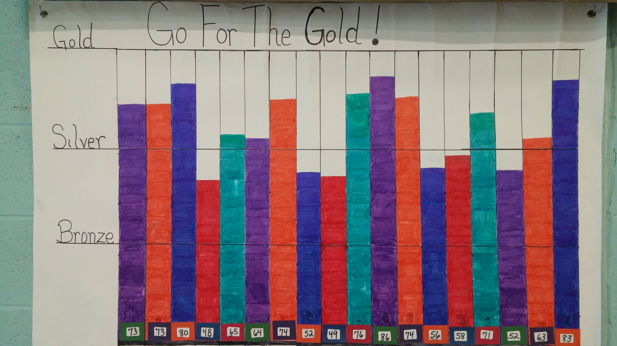
- We use positive language and feedback.
Examples of positive language:
“Thank you for using quiet walking feet in the hallway.”
“Great job using a voice-level of 0 while you work.”
“I love how you use kind words when talking to your classmate.”

Oak Grove’s School Matrix
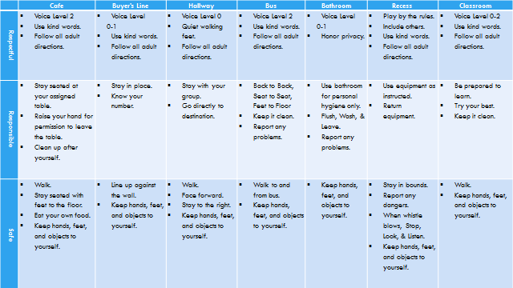

Example: Oak Grove’s Hallway Expectations
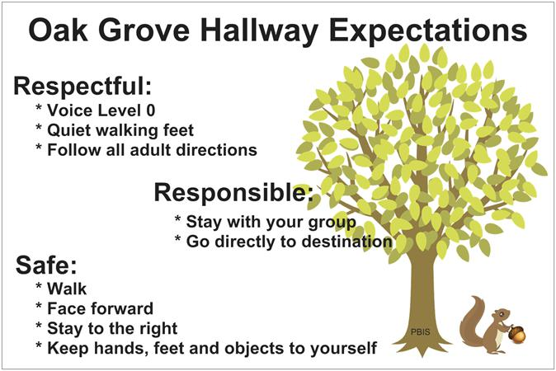
(These posters are hanging throughout the school for students to see!)

